**Skywatcher Driver Installation v 1.1:**

**Download and Installation:**

Both the plugin and the sources are available -see <https://rti-zone.org/macosx_x2mount_plugins.php>. Download the relevant package and follow the installation instructions./

For the OS X package, remember to set your "Allow apps downloaded from:" settings in the "Security & Privacy" system preferences to "Mac App Store and identified developers".

This zip file contains the installable pkg : [Skywatcher mount X2 OS X Plugin version 1.0](https://rti-zone.org/files/Skywatcher_X2_OSX.zip)

The Windows zip file contains the needed files and an INSTALL.TXT with the explanation on how to install it : [Skywatcher mount X2 Windows Plugin version 1.0](https://rti-zone.org/files/Skywatcher_X2_Windows.zip).

The RPI-3 tgz file contains the needed files and an INSTALL\_RPI.TXT with the explanation on how to install it : [Skywatcher mount X2 RPI-3 Plugin version 1.0](https://rti-zone.org/files/Skywatcher_X2_RPI.tgz).

The Linux Ubuntu tgz file contains the needed files and an INSTALL\_Ubuntu.TXT with the explanation on how to install it : [Skywatcher mount X2 Linux Ubuntu Plugin version 1.0](https://rti-zone.org/files/Skywatcher_X2_Ubuntu.tgz).

The plugin source code is available on GitHub : [Skywatcher mount X2 Plugin sources](https://github.com/rpineau/Skywatcher" \t "_blank). To compile the plugin yourself, you'll need the [X2 Example](http://www.bisque.com/sc/media/p/41169.aspx) code from Software Bisque. This is not required if you only want to install the plugin.

**Initial Settings:**

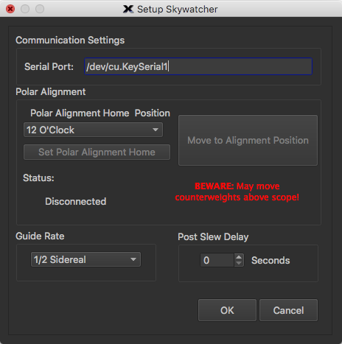1. Run TSX and select your mount - you should find a category "Skywatcher EQ Mount", with one option "Skywatcher". Select this mount.

2. Select "settings" for the mount. The most important is the serial port name for your device. Plug in your normal EQDIR cable and look at the /dev directory. On Linux, USB serial devices are created incrementally on the /dev file system and often appear as /dev/ttyUSB0, /dev/ttyUSB1, or /dev/serial, /dev/serial1. You are likely to be using a cable based on the FDTI chip - Richard has already installed a rule which will create a device /dev/FDTIusb . You'll see your device appear and disappear from the directory as you plug and unplug the usb cable. Type this name into the mount settings box. If you have multiple devices, you might find that the names change depending on the order you connect to the Pi - if that's the case, take a look at the tutorial below to make the device name persistent:

<http://indilib.org/support/tutorials/157-persistent-serial-port-mapping.html>

On OS X (aka macOS), the new port will also appear in /dev/ as /dev/tty.usbserial-FTXXXXXXX, XXXXXXX being the serial number of the FTDI chip. This will never change for a given adapter, so no need to check every time.

3. The next group of settings can be used for polar alignment - (much like the same scheme in EQMOD) - see the section later for instructions.

4. You can set the guide rate for the ST4 port on your mount using the guide rate drop down list.

5. You can also set an optional delay after a slew using the spin box - use this is you find that your Closed Loop Slews or Tpoint images show the scope is still moving when these are taken.

5. Once you have set the serial port name, close the settings and hit connect.

From then on, you should be able to slew, park, set tracking rates and move and jog the mount using the controls on the telescope tab. The one big restriction at the moment is that you can't pulse guide - if you want to guide, you'll need to use a guide camera with an ST4 port.

**Polar Alignment:**

If you have used EQMOD, this idea is stolen (with pride!) from there. The idea is first to record the orientation of the polar alignment reticule. Once the driver knows this, it can set the correct orientation of the reticule to allow you to polar align. I've found I can get within 5 arc minutes of the pole using this technique, more than good enough for guided and unguided imaging (the PE is the limitation for unguided images). If you have not used this approach before, read the instructions here first.

[http://eq-mod.sourceforge.net/docs/PolarScopeAlignment.pdf](http://eq-mod.sourceforge.net/docs/PolarScopeAlignment.pdf%20)

Northern hemisphere:

*Recording Orientation of the Polar Alignment Reticule*

1) Use the normal TSX controls to move the mount so that you can see through the polar scope (tip - use the Navigate command under the Orientation menu. Set DEC = 0 and chose and pre-meridian RA if you want the scope to point to the left, a post-meridian RA if you want the scope to point to the right). Make sure you put the mount in the normal starting position (scope pointing North, counter weights down) before you turn on the power and connect the mount. Some people mark the starting location for improved repeatability.

2) Look through the polar scope and adjust the Alt/Az bolts to place Polaris to the centre of the reticule.

3) Choose a starting position of 3, 6, 9 or 12 o'clock using the drop down list on the mount settings dialog - choose the one that makes it easiest to move without any collisions if your scope is mounted.

4) Using only the Altitude bolts if you have chosen 6 or 12 o'clock, or just the Azimuth bolts for 3 or 9 o'clock, move Polaris so that it intersects the circle - see the EQMOD file for figures.

5) Now using the telescope controls, change the RA of scope until Polaris is in the centre of the Polaris indicator (bubble), or some easily remembered marker (e.g. 6 o'clock) on the newer reticule.

6) When aligned, click the button "Set Polar Alignment Home". The button "Move to Alignment Position" should now be enabled.

The steps above only need to be performed once - the driver will remember the location of the reticule. For subsequent nights, you only need to follow the step below.

*Moving to Alignment Position*

7) The final step is straightforward - just press the "Move to Alignment Position". The scope will slew in DEC to the same location as before, and in RA so that the reticule is in the correct position.

8) Use the Alt/Az screws to move Polaris to the marker you used in step 5.

The mount should now be polar aligned to within a few arc minutes.

Southern hemisphere:

The procedure is exactly the same except that the marker for Sigma Octanis (the star closest to the pole on the reticule) is used instead of Polaris. Unlike in EQMOD, there is no choice of which of the quartet of stars to use. However, any star reasonably close to the pole (or indeed any fixed object that can be seen in daylight) can be used for steps 1-6 since it is simply used as a marker to record the orientation of the reticule.

For steps 7 and 8, each star in the quartet should be visible in the reticule.